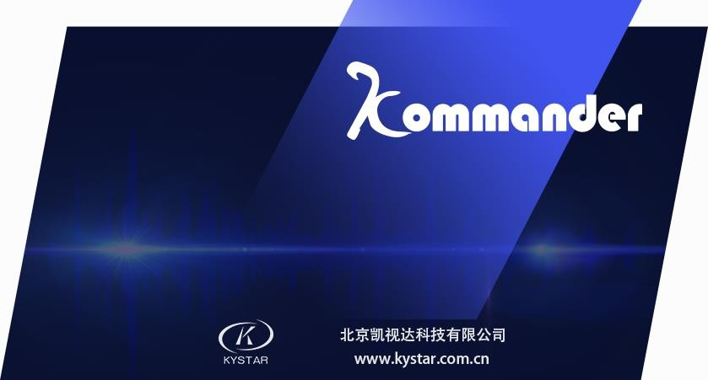

Kommander T1 User Manual

Service Hotline: 400-159-0808
Official Website: www.kommander.com.cn
Public Account: Kommander2011

Table of Contents
Introduction....................................................................................................................................
1. Overview................................................................................................................................
2. Software operating environment................................................................................................................
I. Software installation..........................................................................................................
II. Kommander T1 interface introduction.......................................................................................
1. Kommander T1 software screenshot......................................................................................
2. Kommander T1 software interface function introduction..........................................................
III. Kommander T1 software use process............................................................................
1. Switch computer display mode.........................................................................................
2. Run software........................................................................................................................
3. New project........................................................................................................................
4. Plan file setting................................................................................................................
5. Add material........................................................................................................................
6. Set screen management................................................................................................................
7. Play content edit................................................................................................................
8. Play plan creation................................................................................................................
IV. Other functions.......................................................................................................
1. Picture rotation........................................................................................................................
2. Feather function........................................................................................................................
3. Play schedule management...................................................................................................
4. Boot self-starting management..............................................................................................
5. Online software update................................................................................................................

Introduction

1. Overview

Kommander T1 is a kind of LED display screen broadcast control software with a concise interface style. The software has abundant functions, easy to learn and easy to use. Users could fully enjoy the most popular broadcast control platform of high quality. Kommander T1 Supports the broadcast of media files such as video, audio, image, office and streaming media etc.; supports the use of small tools such as clock, timing, weather forecast etc.; supports collection and broadcast of external video signals. The software provides abundant and flexible material switching function, and perfectly reflects the display effect of the display screen.

2. Software operating environment

Users could adjust machine configuration according to actual situation, mainly based on LED screen pixels, complexity of programs and whether the video is a high definition video source etc.
Recommended configuration
  Operating system
Chinese/English Windows7/8/10 64-bit operating system
  Hardware configuration
CPU: Core i5 or higher
● Memory: 4G or higher
● Video card: GTX950 or higher

I. Software installation

Double click Kommander_T1_Setup_X64.exe installation file, and install according to software installation wizard.
Select whether to agree with the protocol, and go to the next step,

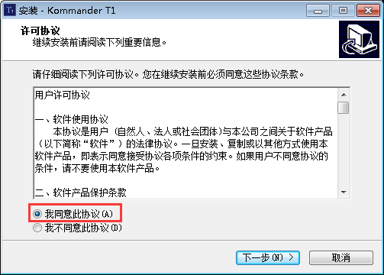

select software installation path,

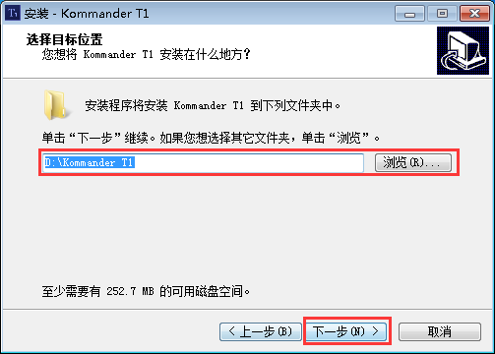

click "Install",

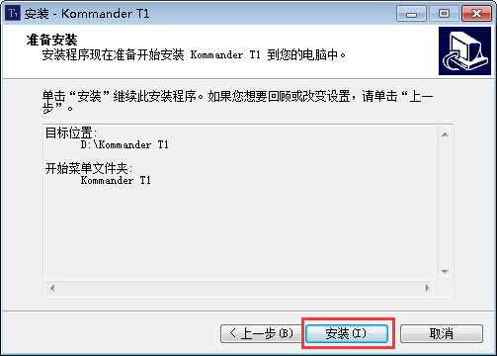

click "Finish" and run T1 software.

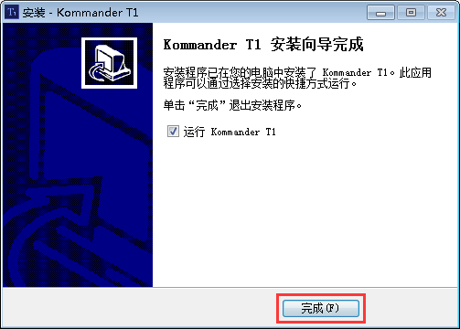

After software is installed successfully, KommanderT1 program group will display in [Start]/[Program], enter Kommander T1 under the program group, and click to run, meanwhile, Kommander T1 shortcut icon will also display on desktop, double click to start the program.

II. Kommander T1 interface introduction
1. Kommander T1 software screenshot

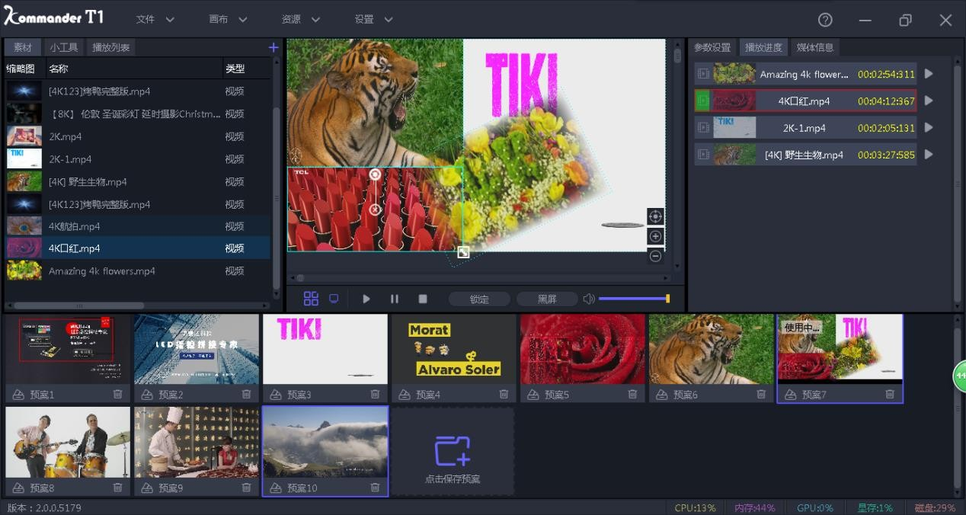
2. Kommander T1 software interface function introduction

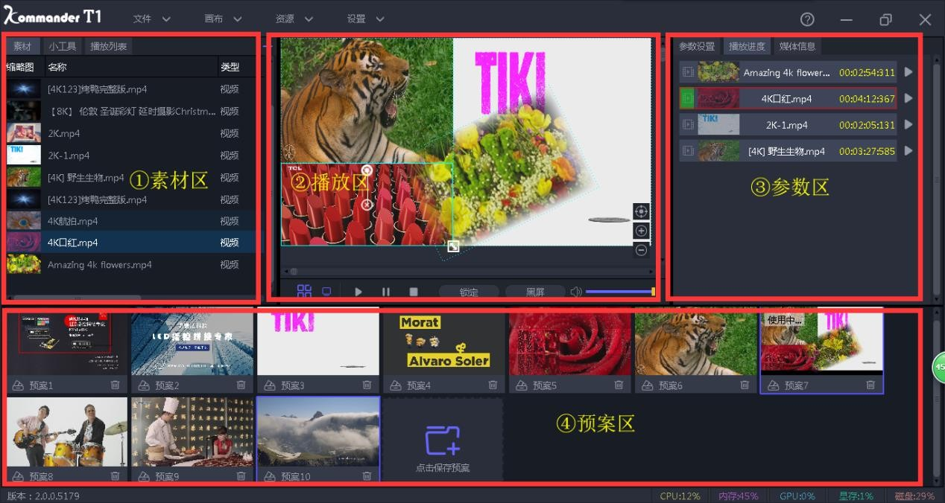
The Kommander software interface could be divided into four major function zones, namely:
① Material zone, ② Play zone,
③ Parameter zone, ④ Plan zone
① Material zone: Material and its information display zone
② Play zone: Material play zone
③ Parameter zone: Parameter display and setting zone
④ Plan zone: Play plan generation zone

III. Kommander T1 software use process

1. Switch computer display mode
Switch the computer to extension mode, the shortcut method: windows key + P key

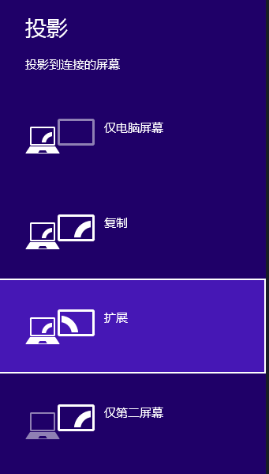
2. Run software
Double click the software icon to run Kommander T1 play software

3. New project
Click "New" to create a project file.

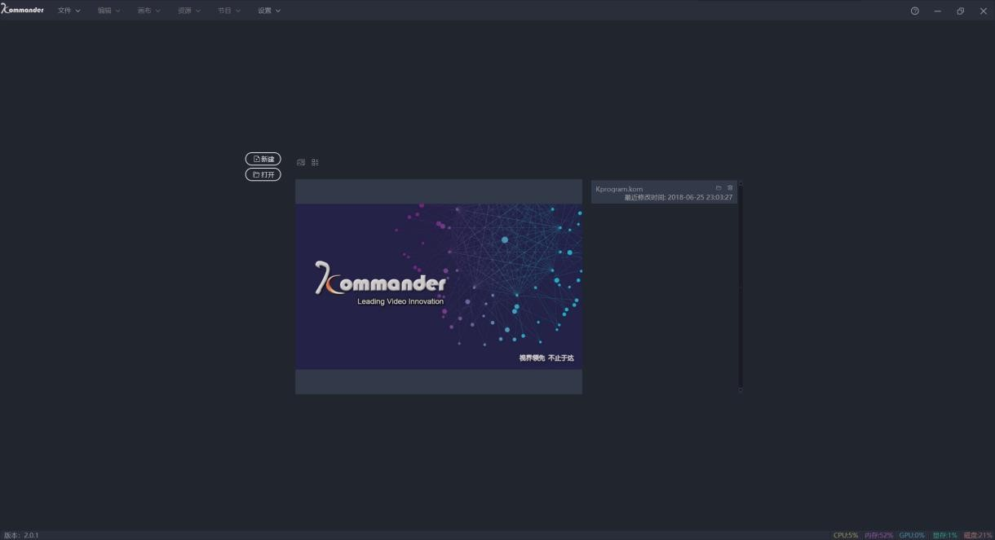

4. Plan file setting
Click plan name and select save path, and click "OK" to complete the creation of the project file.

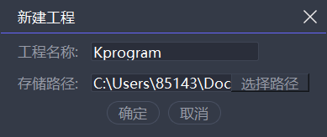

5. Add material
After a play plan is created, enter the system main interface, right click the mouse in the material resource zone to add material, and select corresponding option according to material type required to be added.

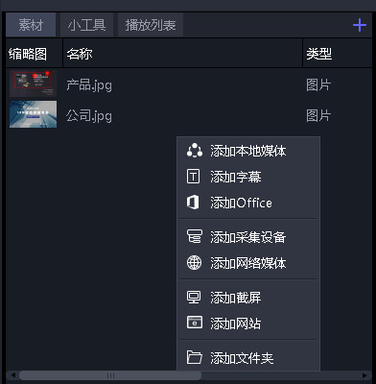

The system supports adding multiple play resources including: Local media, subtitle, office file, collection card, streaming media, website, and screenshot.
Local media: Video files of various formats

Subtitle: Edit subtitle file, and add subtitle on video or picture.

Website: Add webpages

Screenshot: Add screenshot, and display local real-time display screen. Collection card: Add collection card device signal source.
Streaming media: Add streaming media video.

Office files: Add Word and PPT files (Office2010 is required to be installed on the computer)

6. Set screen management
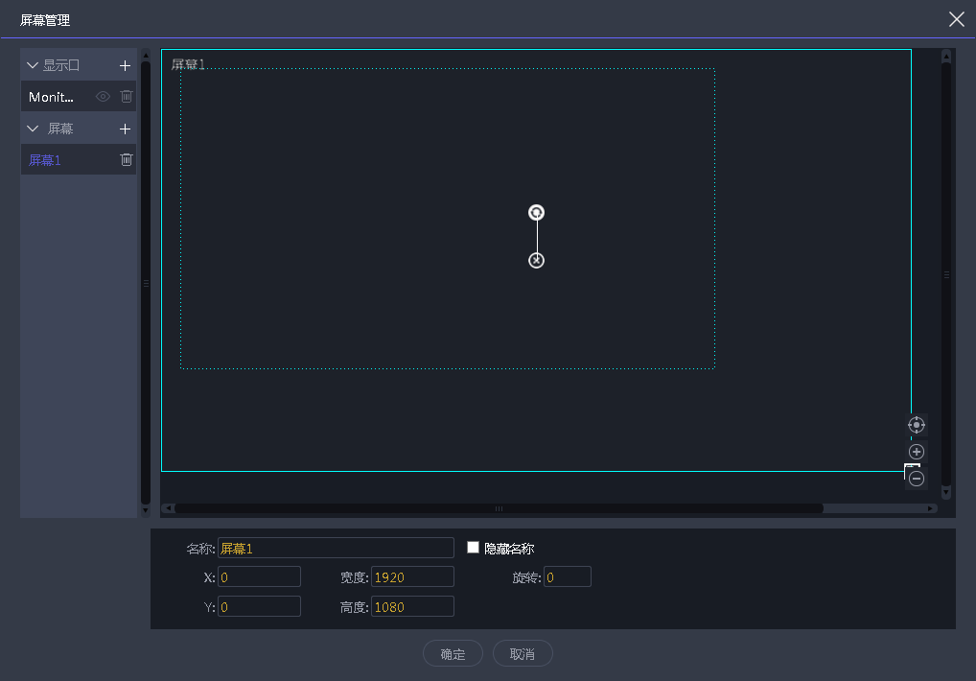After adding the material to be played, set screen configuration according to actual dimension of LED screen, and click 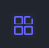 to enter the screen management interface.

Display port: The software will add display port automatically, with a resolution consistent with actual extension screen.
Screen: Manually add screen number, and drag randomly within the range of display port, while the video dragged into the screen will fill the screen automatically.
Name: Custom naming for the added screen. Hidden name: Select whether to hide screen name, and the name will only display on local display.
Set 3 screens namely left screen, center screen and right screen, click OK, as shown in the following figure:

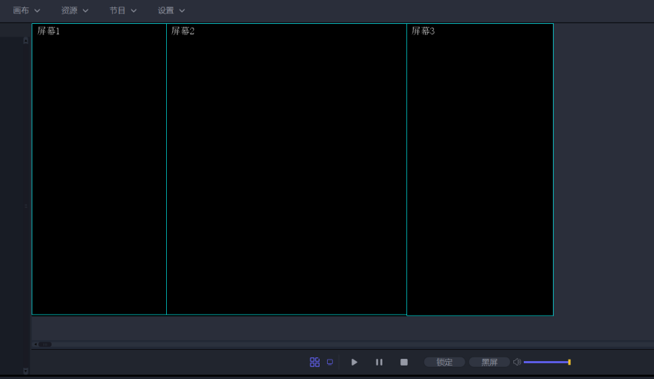

7. Play content edit
Drag materials from material resource zone to three screen points and click Play. During the play process, you can place new material to the edit zone, to realize real-time replacement of material content, as shown in the following figure:

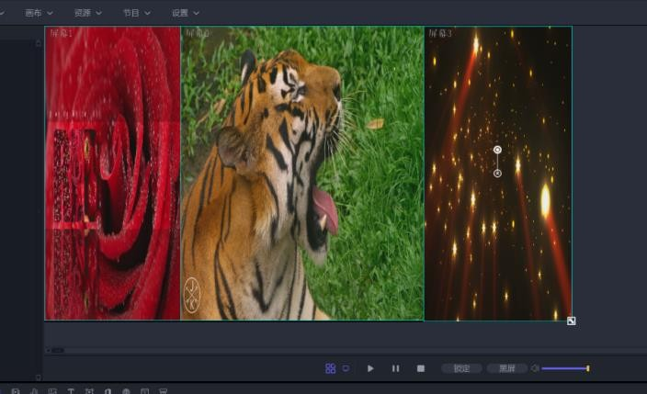

8. Play plan creation
Right click the mouse in the edit zone, and select "Save as play plan", to generate the play plan in the plan zone. The play plan is a frame of screenshot in the edit zone, as shown in the following figure:

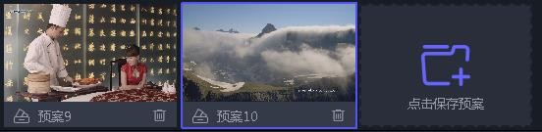

According to actual requirements, edit the required play content plan and generate in the plan resource zone, as follows:

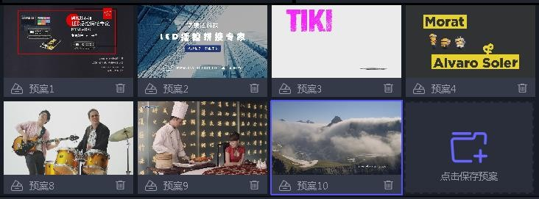

After editing the play plan, clear materials in the edit zone, double click Plan in the play plan zone, and click Play, to display the video play mode saved previously onto the large screen, and the switching effect between play plans is fade-in fade-out.

IV. Other functions

1. Picture rotation
In the material monitoring zone, via the knob on the material, rotate the material by any angle, or click the material, and set the rotation angle in the information status bar to rotate the material.

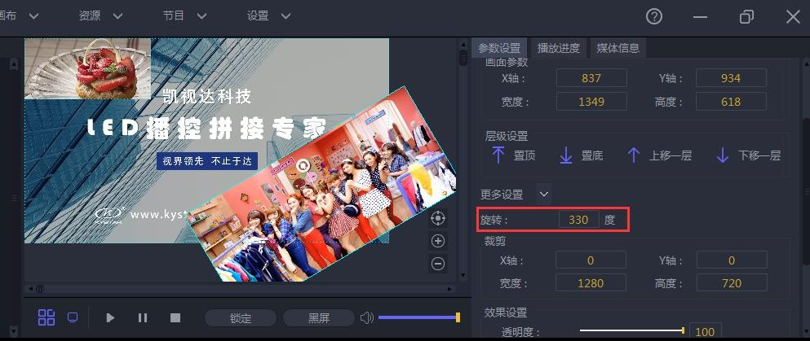

2. Feather function
Via feather setting, conduct feather on material in PIP, to make edge transition between different materials more natural.

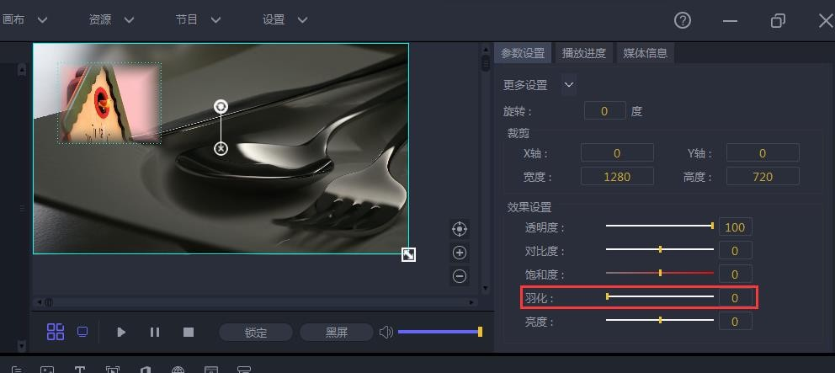

3. Play schedule management
View the time schedule of material play in the "Play schedule", when the video play is near the end, the progress bar becomes red. Via corresponding pause button on the progress bar, pause the playing of corresponding material.

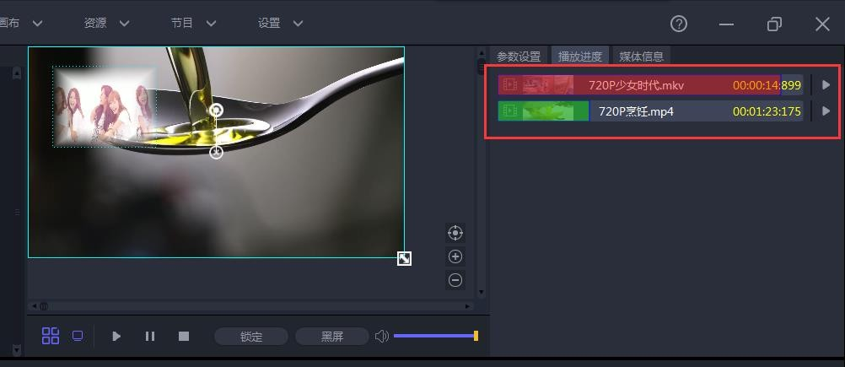

4. Boot self-starting management
Via setting software self-starting and loading plan, realize unmanned automatic carousel function. First select "Boot self-starting" and "Open project after program starting" function in "System settings" in "Software settings", to realize boot self-starting.

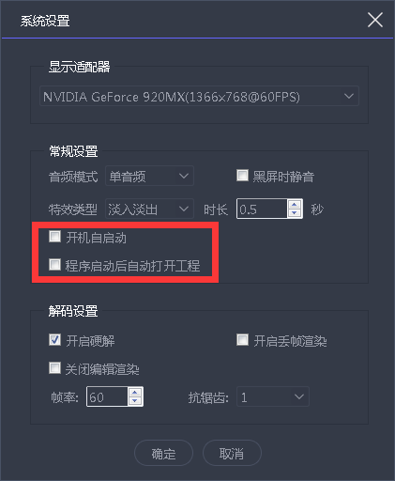

Via "Timed setting" in "File", set to execute corresponding play command in specified time.

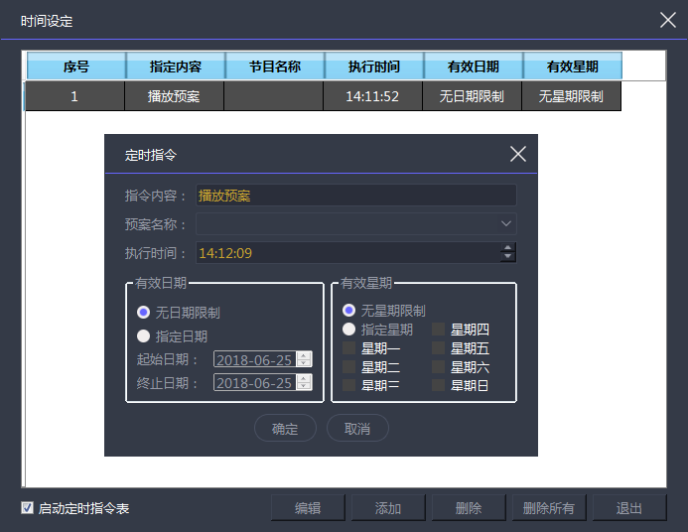

5. Online software update
The online update of software version could be realized via "About product" in the upper right corner of the software.

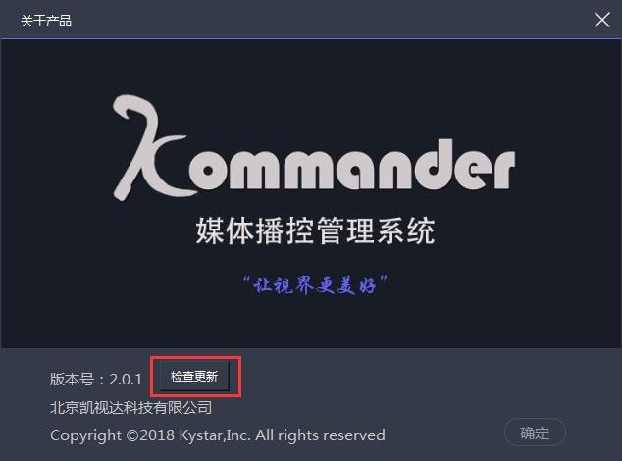

To understand more products, please go to website www.kommander.com.cn.

